SPRINT-1

# TEAM ID: PNT2022TMID12310

PROJECT NAME: IoT based smart crop protection system for Agriculture

**Bird’s detection circuit:** Protect the fruits and vegetables from the birds by using Piezo electric buzzer with Arduino.

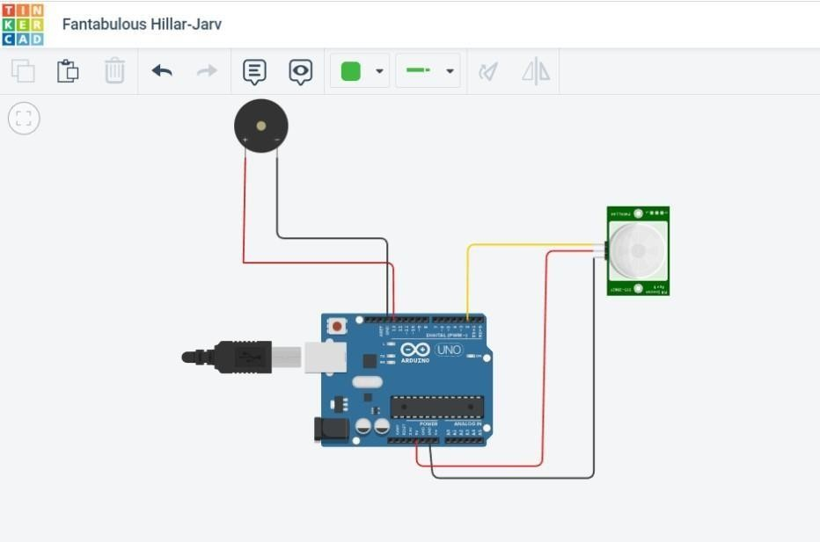

# Moisture circuit: To detect the moisture level in the soil

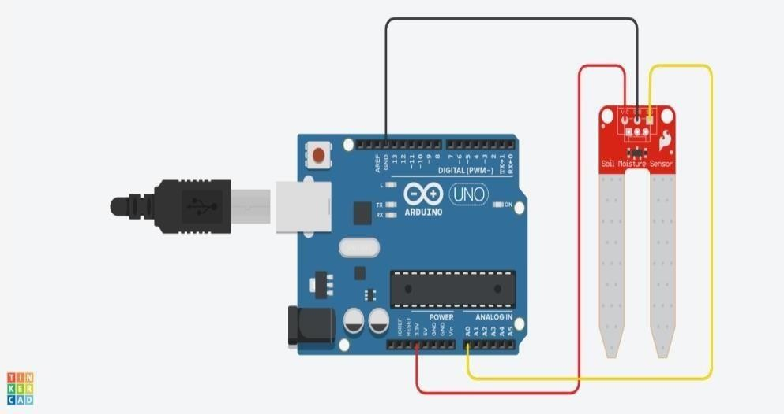

## Animal detection circuit: without fencing, to detect the animal entry in the field

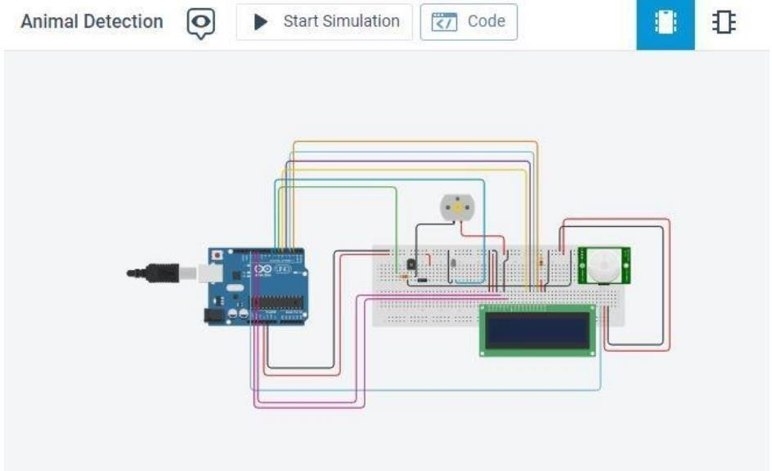

CODE:

## Birds detection circuit: Protect the fruits and vegetables from the birds by using piezo electric buzzer with Arduino

void setup()

{

pinMode(2,INPUT); pinMode(13,OUTPUT);

}

void loop()

{

if (digitalRead(2)==HIGH)

{

digitalWrite(13,HIGH);

}

else

{

digitalWrite(13,LOW);

}

delay(10);

}

## Moisture circuit: To detect the moisture level in the soil

int moistureValue;

float moisture_percentage; void setup()

{

Serial.begin(9600);

}

void loop()

{

moistureValue = analogRead(A0); moisture_percentage = ((moistureValue/539.00)*100); Serial.print("\nMoisture Value : "); Serial.print(moisture_percentage);

Serial.print("%"); delay(1000);

}

## Animal detection circuit: without fencing , to detect the animals entry in the field

#include<LiquidCrystal.h> LiquidCrystal lcd(11,12,5,4,3,2); int led = 7;

int pirPin = 13; void setup(){

pinMode(6,OUTPUT); lcd.begin(16,2); pinMode(led, OUTPUT); pinMode(pirPin, INPUT); Serial.begin(9600);

}

void loop()

{

lcd.blink();

int a = digitalRead(pirPin); Serial.println(a);

if(a==HIGH)

{

lcd.setCursor(1,1); lcd.print("Animal Detected"); digitalWrite(led, HIGH); digitalWrite(6, LOW); delay(2000);

lcd.clear();

}

else

{

digitalWrite(led, LOW); digitalWrite(6, HIGH); lcd.clear();

}

}